Aerobatics Black Box

Darcy Meyer, Pai Liu, Rex Patel, Wenjun Ma, Xinyu Liu

**Project Summary**—During aerobatic flight, pilots would like to correlate their control inputs to the airplane’s behavior and to be able to visualize what the maneuver looked like from the ground. As a result, we are going to design an Aerobatic black box system which contains two parts. First, a hardware data collecting system can collect attitude (by AHRS), position (by INS), control input, and flight gauges (by camera). Second, simulation software can process the data and generate the aircraft maneuver from the judge's position. The system can help the pilot to learn flight, and also provide a better method for practice.

————————————————

* *Darcy Meyer is with the Department of Electrical and Computer Engineering, Boston University. E-mail: darcym@bu.edu.*
* *Pai Liu is with the Department of Electrical and Computer Engineering, Boston University. E-mail: paiii@bu.edu.*
* *Rex Patel is with the Department of Electrical and Computer Engineering, Boston University. E-mail: rexu6@bu.edu.*
* *Wenjun Ma is with the Department of Electrical and Computer Engineering, Boston University. E-mail: wjm123@bu.edu.*
* *Xinyu Liu is with the Department of Electrical and Computer Engineering, Boston University. E-mail: xinyubu@bu.edu.*

—————————— ◆ ——————————

# 1 Need for this Project

Aerobatic performances are very different from ordinary flying tasks. General pilots use scientific methods to avoid risks during training, while aerobatic pilots take the initiative to face risks and use their lives to challenge the limits of aircraft performance and flying skills. In the field of aerobatics, there is no limit to the exploration of pilots' flying skills. In different aerobatics, the aircraft's flight status, altitude, speed, direction, and overload parameters change drastically. The pilot must be aware of the flight status at any time, understand the changes in motion parameters, and control the aircraft to move on a predetermined trajectory in a timely and accurate manner. During competition training, ordinary avionics cannot record and replay flight maneuvers, and pilots cannot make precise movement adjustments based on the judges’ viewpoint.

In order to help pilots to understand the status of the aircraft, the AHRS came into being, which can help pilots understand the real-time aircraft attitude. However, this system lacks 3D playback of aerobatics, cannot help the pilot to watch the aircraft attitude from the referee's point of view, and cannot record real-time pilot input, which does not meet the needs of an aerobatic pilot during training.

Our Aerobatic Black Box will address these issues by providing a hardware part which contains AHRS, INS, and a camera to collect pilot input; a software part which allows pilot replay flight maneuvers; and also provides pilot input corresponding to those maneuvers. Aerobatic Black Box is specially designed for introductory aerobatics pilots and aerobatics training. This system will allow pilots to observe different angles of flight attitude for the next flight adjustment, and also solves the lack of digital AHRS in some aircraft, and greatly reduces the difficulty of aerobatics training.

# 2 Problem Statement and Deliverables

## 2.1 Problem Statement

Our system not only displays and records the visualization of the plane’s status over the map during the flight but also records the pilots’ inputs, all of which can be viewed after the flight. In reality, multiple devices can display and record the flight data, but no individual one can display the direct view of the plane’s status, and it is impossible to record pilots’ input. In our system, we incorporate data from the AHRS and INS systems with the visualization of the flight from the judge’s position, so the pilots can easily see the plane’s behaviors, and they can compare their input with the plane’s motion after flying. Also, our system can record the data from the flight gauges such as the airspeed and engine speed. This can help some beginners to see the difference between their inputs and the actual plane’s status. Furthermore, our system has to be easy to install and remove, and the pilots should not have to interact with it during the flight.

## 2.2 Deliverables

1. A Central Data Processing Unit
   1. Stores pilot’s inputs and data from AHRS and INS
   2. Process the data for input to a 3D model of the plane’s behavior from the AHRS and INS
   3. Incorporate the plane’s behaviors with the pilot’s inputs
2. AHRS/INS Sensing
   1. Record the plane’s absolute altitude, acceleration, and angular rotation
   2. Record the plane’s orientation, position, and velocity without any external reference point
   3. Send the recorded data to the Central Data Processing Unit
3. Plane Sensing
   1. Capture the pilot’s mechanical input from the cockpit of the plane
   2. Record the airspeed from the pilot’s dashboard
   3. Send the recorded data to the Central Data Processing Unit
4. User Interface
   1. Display a 3D visualization of the plane’s position over time
   2. Display the pilot’s inputs alongside the plane’s recorded behaviors

# 3 Visualization

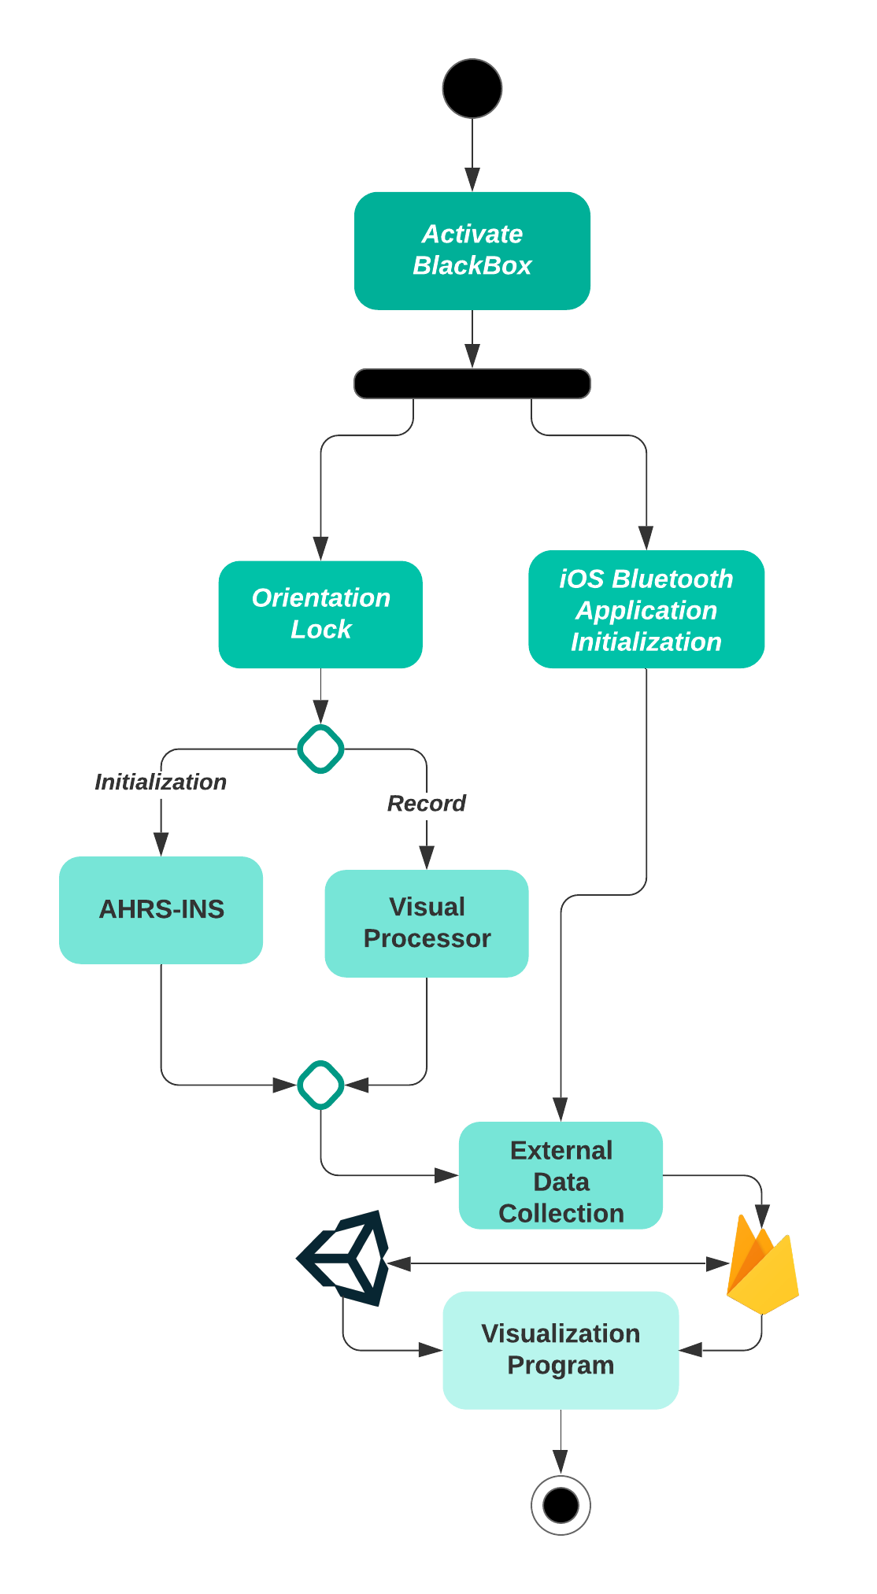

Fig. 1. Process flow for the Aerobatic Black Box.

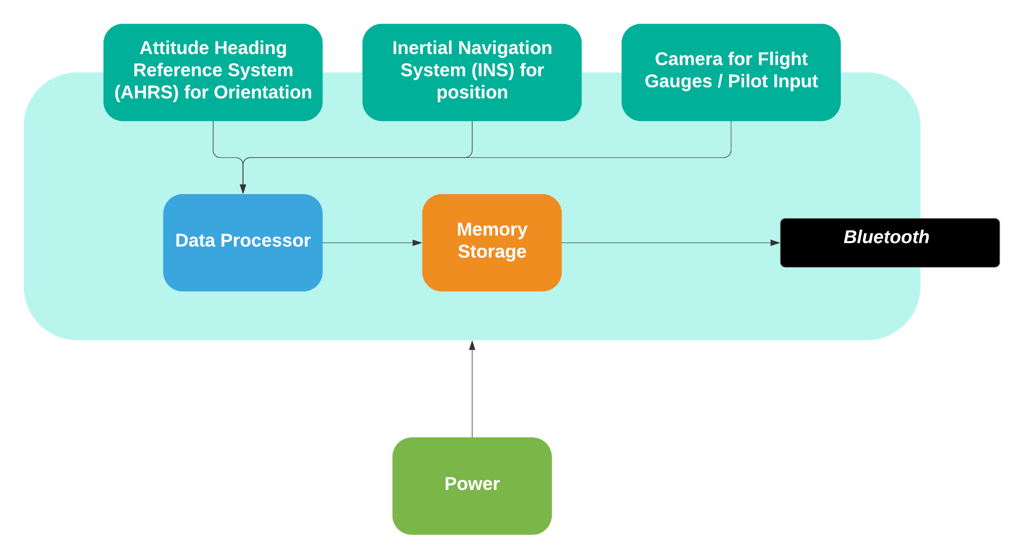

Fig. 2. Hardware Architecture for the Aerobatic Black Box.

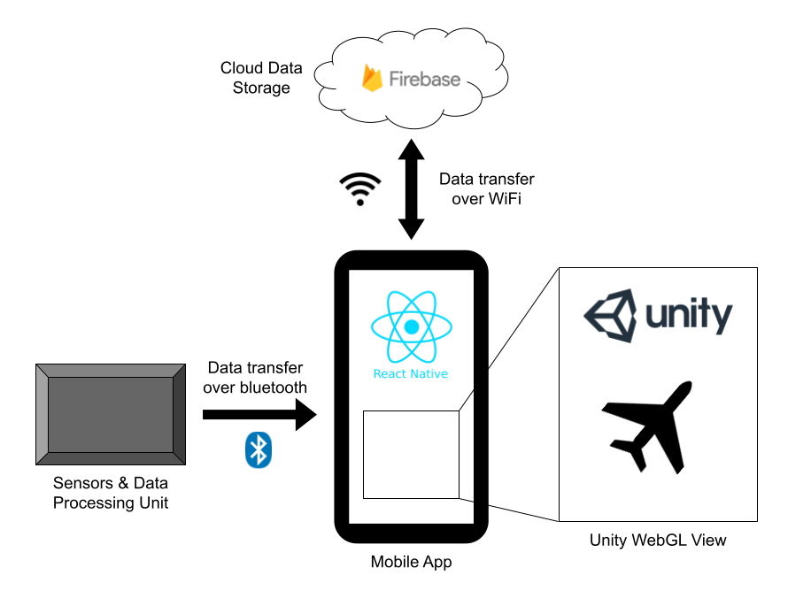

Fig. 3. App architecture supporting the 3D visualization

# 4 Competing Technologies

## 4.1 Data Comets

Data Comets [1] is designed for Unmanned aerial vehicles (UAVs). Generally, the project is to design a visualization tool for analyzing autonomous aerial vehicle logs with grounded evaluations. Its main fundamental function is to visualize the Autonomous Aerial Vehicle flight path and communicate the flight logs with ground. This technology has a high similarity to our project since both projects are aiming at the plane and the log of the plane.

The first thing which interests us is its requirement for monitoring pilot input, since we are told that it is not allowed for us to import any data from the plane.

After that, we notice there are also some advantages in its user interface, it will display three main views: the map, attribute tree, and timeline. In the maps, the flight path, setpoints and predicted flight path can be optionally shown. The timeline shows the velocity of the whole flight and could adjust what section of time the user would want to watch. In our project, we are trying to improve and incorporate these three functions into our project. In the map view, our project is trying to not only visualize the flight path but also what the maneuver looked like from the ground. Moreover, we also want to develop the function of setting setpoints and desired flight path in further development. In the attribute tree view, our requirements are adjusted to show the most pilot inputs like roll angle and pitch angle, air speed, altitude, and velocity. Since most of the clients are interested in competence, with these functions, users can easily review the flight and find what they could improve to better drive the flight.

## 4.2 Xsens

The MTi-3 [2] is a self-contained Attitude and Heading Reference System (AHRS) which delivers true North-referenced yaw, or heading.

Specifications:

1. 0.5 deg RMS for roll and pitch
2. 2 deg RMS for yaw and heading
3. Standard full range: 16g, In-run bias stability: 30 µg and noise density: 120 µg/√H for accelerometer
4. Standard full range: 2000 deg/s, In-run bias stability: 10 deg/h and noise density: 0.007 º/s/√Hz for gyroscope

The engineering requirements for Xsens AHRS are very strict, which directly points out the direction and goal that our project needs to achieve.

## 4.3 Vectornav

The Vectornav [3] VN-100 is a miniature, Inertial Measurement Unit (IMU) and Attitude Heading Reference System (AHRS). Combining 3-axis accelerometers, gyros, and magnetometers, a barometric pressure sensor and a 32-bit processor, the VN-100 provides high-rate, calibrated IMU data and a real-time 3D attitude solution that is continuous over the complete 360 degrees of motion.

Specifications:

1. <2.0° Magnetic Heading Accuracy
2. 800Hz IMU data rate
3. <0.5° Pitch/Roll Accuracy
4. <0.04 mg Accelerator el In-Run Bias Stability

The engineering requirements for VN-100 are very strict, we are also preparing to apply relatively strict requirements to our project to make our project more competitive.

# 5 Engineering Requirements

## 5.1 Data Collection

1. The data collection system must measure and record the position (latitude, longitude, and altitude) and attitude (pitch, roll, and yaw) of the aircraft over time
2. The data collection system must measure and record the positions of the flight stick, rudder pedals, and throttle (collectively the pilot’s control inputs) over time
3. The data collection system must measure and record the value of the airspeed indicator dial located in the cockpit of the aircraft over time
4. The data collection system must continuously record each of the above data points at a frequency of at least 20Hz
5. The data collection system must
6. The data collection system must record a timestamp alongside each of these data points

| Input Symbol | Input | Unit |
| --- | --- | --- |
| α/ψ | Roll | ° (Euler Angle) |
| β/θ | Pitch | ° (Euler Angle) |
| γ/φ | Yaw | ° (Euler Angle) |
| ax, ay, az | Directional Accelerations | m/s2 |
| Lat | Latitude | -  (Geographic coordinate system) |
| Long | Longitude | - (Geographic coordinate system) |
| h | Altitude | feets →m |
| - | Gyroscope | dps (degrees °/ s) |
| t | timelog | milliseconds |

## 5.2 Operating Environment

1. The data collection system must survive temperatures of -40°C to 50°C in storage and 0°C to 40°C in operation
2. The data collection system must continue to collect data according to the Measurement Requirements and remain securely attached to the interior of the plane while under a g-force of at least 15G from every direction
3. The data collection system must survive the vibrations of an aerobatic plane in flight – to be tested in a Citabria 7ECA
4. The data collection system must operate for at least 30 minutes during flight without any interaction from the pilot
5. The data collection system must be powered either by a 12V bus or by battery
6. The data collection system must not modify any part of the aircraft, in compliance with FAA regulations

## 5.3 Visualization System

1. The visualization system must provide a 3D representation of an aerobatic flight reconstructed from the flight data recorded by the data collection system
2. The visualization system must allow the user to view the flight from any camera angle
3. The visualization must play at 20Hz or more

# 6 Appendix A

## 6.1 References

1. Saffo, David & Leventidis, Aristotelis & Jain, Twinkle & Borkin, Michelle & Dunne, Cody. (2020). Data Comets: Designing a Visualization Tool for Analyzing Autonomous Aerial Vehicle Logs with Grounded Evaluation. 10.31219/osf.io/a4hfd.
2. *MTI-3 Ahrs*. Xsens. (n.d.). Retrieved October 23, 2021, from https://www.xsens.com/mti-3.
3. *VN-100 IMU/Ahrs - vectornav.com*. (n.d.). Retrieved October 23, 2021, from https://www.vectornav.com/docs/default-source/datasheets/vn-100-datasheet-rev2.pdf?sfvrsn=8e35fd12_10.